Module Code (FC723)
Class/Group: (Group C)
Module Title (Programming Theory)
Assessment Title (Portfolio Assessment 2)
Tutor Name: (Sophie Norman)
Student GUID Number: (3075614)
Date of Submission: (9th February 2025 at 23:59)

I confirm that this assignment is my own work.
Where I have referred to academic sources, I have provided in-text citations and included the sources in the final reference list.

ID:3075614 , Module: FC723 , Sophie Norman.

What is the project?

The project is a banking app that the users can interact with it using command line interface (CLI).Firstly users have to use the app under Username that they Create and password, password should be between 8 to 16 characters. The app main services are Withdraw, Display balance, Deposit and Transfer money. All users have overdraft allowance that they can use when withdrawing money but not transfer money. If some one try to access account and entered the wrong password three times the account will locked out, which means no one can access the account or transfer to the account. The app store balance in another file in 2’complement but displayed to the users in decimal.

How I carried out this project?

I began by drafting a brief pseudocode for each function to outline their implementation. Then, I proceeded to write the actual code. When I write pseudocode for something that I think I am not sure about how to structure it, I try to write only skeleton to see what I need to do, then try to write the code and play with it until I understand the path that I should work on.

Scalability.
The app is scalable because of using the Object oriented programming approach, I Used constructor method and passed list of accounts (dictionaries) as an attribute, this will allow the app to get scalable. For example we could create another class and inherit the class BankingApp but passed a new list off special accounts for special clients add their special methods on the new class.
So the special clients will get feature same as normal users and more.

ID:3075614 , Module: FC723 , Sophie Norman.

How does it works?
First we start with the initial Menu. This menu options are Sign in, Log in and exit app. After the user choose an option the initial menu takes the information needed then let the user access the main app interface.
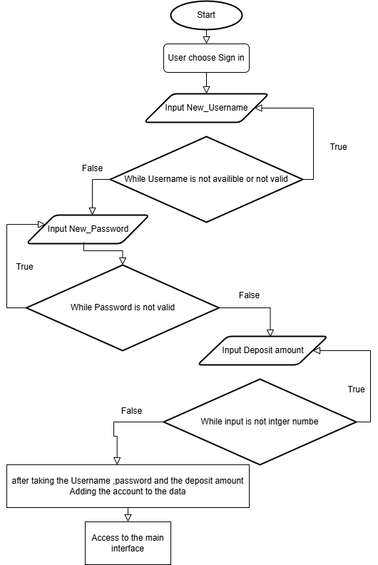
Initial_Menu(self):

This function is triggered when the user selects option 1 (Sign In). Here, a new username is created after verifying its availability and ensuring its valid. Next, a password is set, which must be between 8 and 16 characters long. Finally, the user must deposit an initial amount, ensuring the input is a valid integer. At any point when you choose an option you can enter space then enter to go back.

ID:3075614 , Module: FC723 , Sophie Norman.

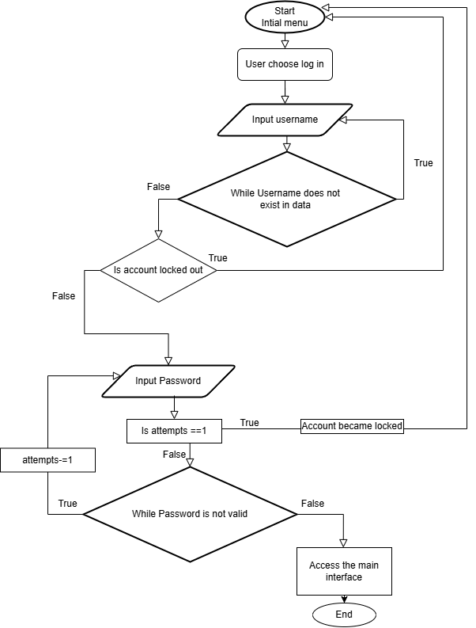
Initial_Menu():
When the user selects option 2 (Log In) to access an existing account, they must first enter their username. If the username does not exist in the system, they will be prompted to enter it again. If the username is found, the system checks whether the account is locked. If locked, the user is redirected to the main menu. Otherwise, they are prompted to enter their password. If the password is incorrect they have up to three attempts to enter the correct one. After three failed attempts the account is locked. If the correct password is entered, the user gains access to the main interface.
Those are all menus in the app.

ID:3075614 , Module: FC723 , Sophie Norman.
Testing.
I used Unit test to tests all the functions.

- Testing Functions in Utilities.py
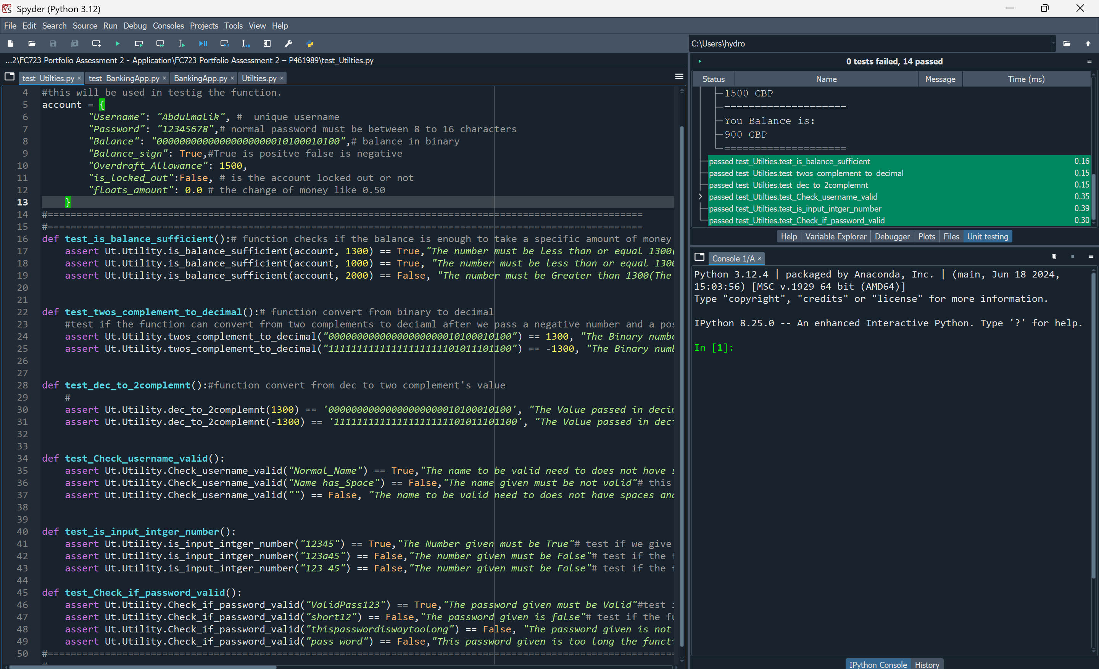
Testing the Utilities.py functions proceeded smoothly without any issues. Because of their simple structure. The only requirement was to set up an account at the beginning of the code to ensure the tests could run properly. I have tested each function by considering all possible inputs, asserting the expected outputs, and running unit tests to verify the results.

ID:3075614 , Module: FC723 , Sophie Norman.

- Testing Functions in BankingApp.py:
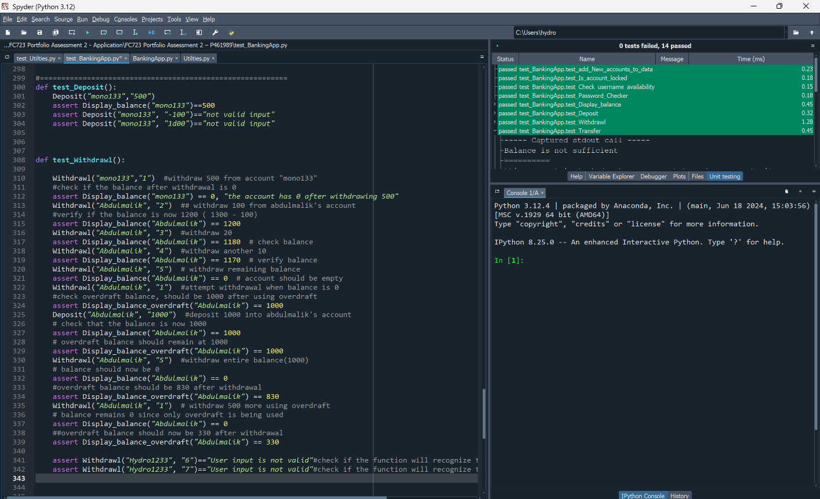

The functions in banking app were hard to test because it require user input using command line. To solve this issue and run tests I took all the functions and put them in the same file of the testing(test_BankingApp.py) and modify them all to take input entered in the parameters of the functions. The withdrawal function has an option which is custom amount I could not do the same in this situation so I added more options that simulate the user input when user choose to withdrawal custom amount. But all the tests worked well after modifying the functions.

A special case I encountered while testing the test_add_New_accounts_to_data function required me to create an additional function to verify whether an account had already been added. This function ensures that duplicate accounts are not created and helps maintain data integrity during testing

ID:3075614 , Module: FC723 , Sophie Norman.

- Bugs that I found.

I discovered a bug during testing of the transfer function, which allowed users to transfer money even when they had no funds. For example, if a user's balance was zero, they could still transfer money, causing the recipient to receive the

funds while the sender's balance became negative. I solved this issue by putting the function Is_balance_sufficient()into the transfer code.

Another bug I found was that if a user entered an incorrect password, they could reset their remaining attempts by returning to the sign-in interface before reaching the maximum of three attempts. To fix this, I stored the number of password attempts in the account list as "Password_attempts": 3. This ensures that even if the user returns to the sign-in interface, the remaining attempts are saved.

- Testing menus:
First the initial_menu()

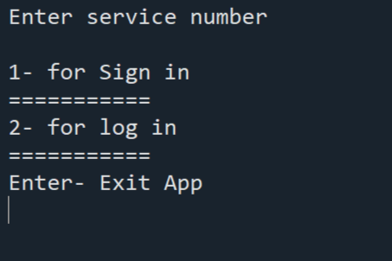
This is what appear first
Users can choose from three available options, and all options function correctly without any issues

ID:3075614 , Module: FC723 , Sophie Norman.

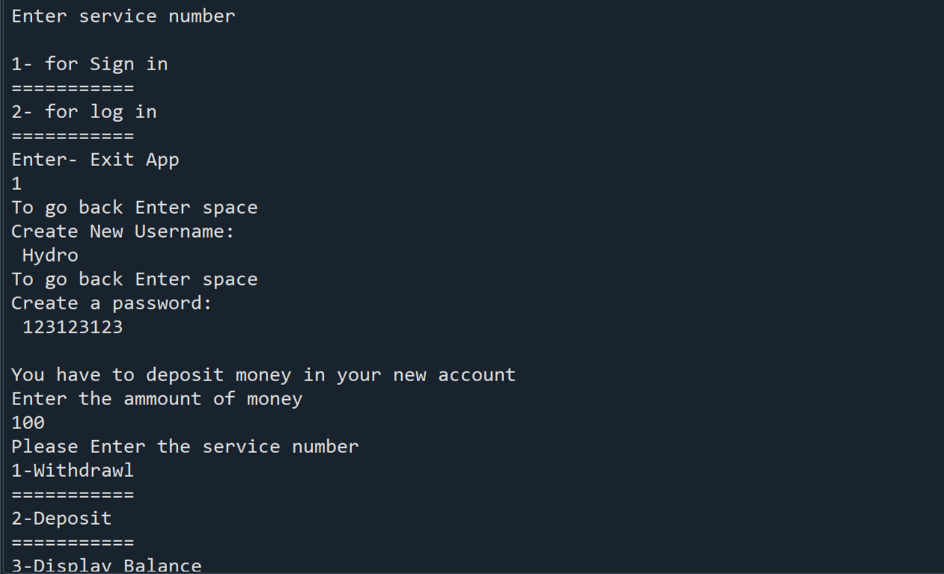
If the user chooses to sign in, they will be prompted to enter their username, password, and the amount of money they wish to deposit. The menu works without issues.

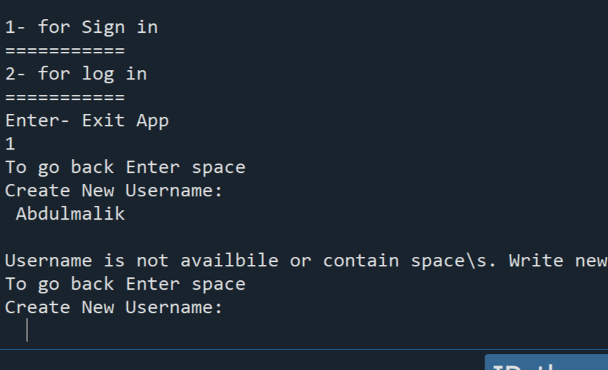
If the user enters a username that is already taken, a message will be displayed, prompting them to choose a different one. This process will continue until the user provides a unique username. The menu functions properly without any issues.

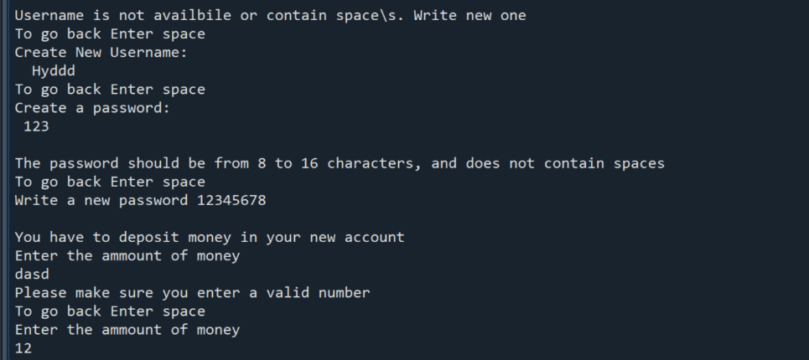

If a suitable username is provided, the process moves to the password entry, which must be between 8 to 16 characters. After setting the password, the user is required to enter an amount for deposit, which is validated to ensure it is a valid number. Once all inputs are correctly provided, the user gains access to the APP_main_interface(). The menu operates smoothly without
ID:3075614 , Module: FC723 , Sophie Norman.
any issues.
If user choose log in:
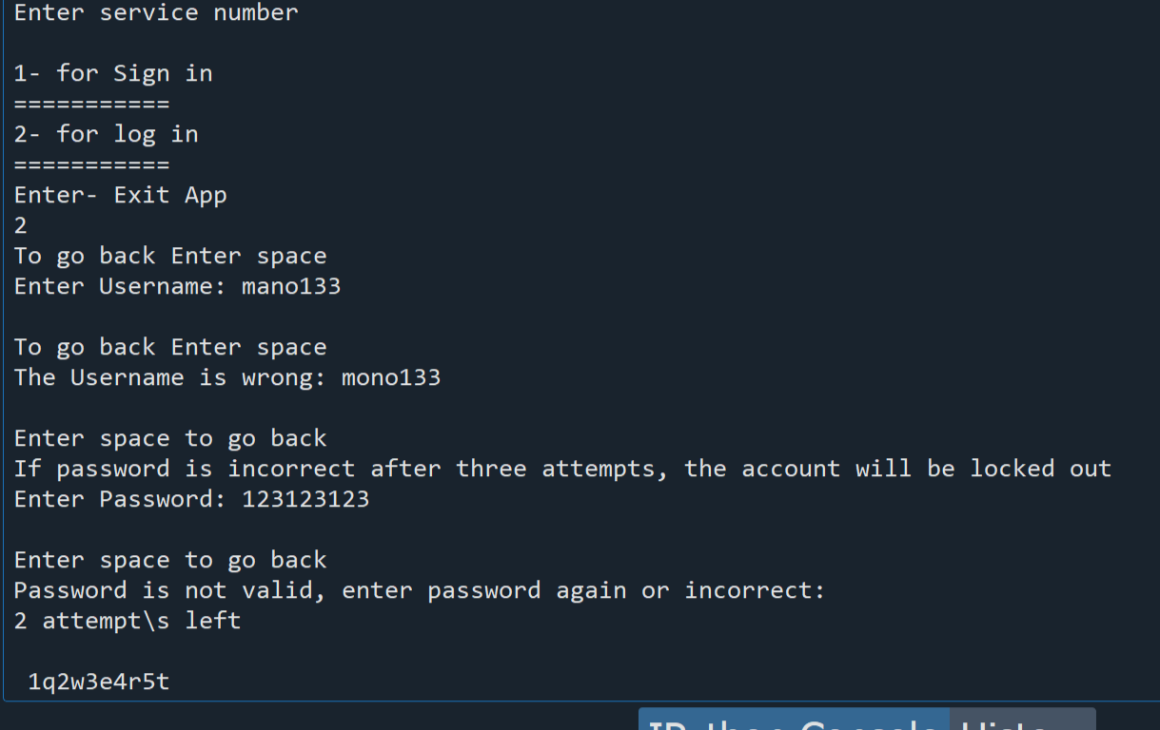

After the user selects option 2, they must enter their username. If the entered username does not exist, they will be prompted to try again. For example, if the user enters 'mano133', it will be checked and found invalid, requiring them to re-enter the correct username, 'mono133'. Next, the user must enter their password. If the entered password is incorrect (e.g., '123123123'), they will be asked to try again, with two attempts remaining. If the user fails all three attempts, the account will be locked. However, if they enter the correct password (e.g., '1q2w3e4r5t'), they will gain access to the APP_main_interface().
The menu functions correctly without any issues

ID:3075614 , Module: FC723 , Sophie Norman.

- App_main_interface()
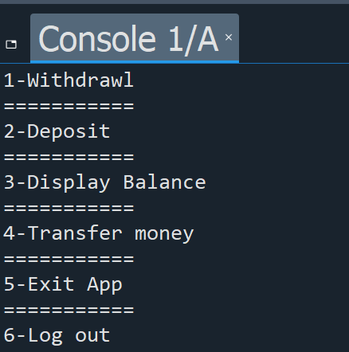
the main interface is designed to display the primary features of the app. it will continuously reappear whenever the user enters anything other than the designated service numbers. the menu functions correctly without any issues.
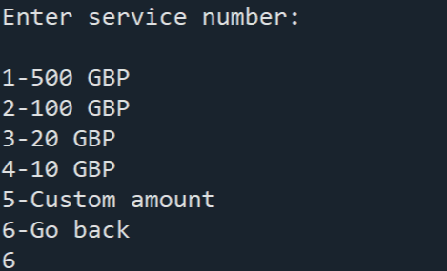
when the user selects the withdrawal option, they will be prompted to enter a valid amount. this prompt will keep appearing until the user provides a correct value. any invalid input will be rejected. the functionality works as expected.

ID:3075614 , Module: FC723 , Sophie Norman.
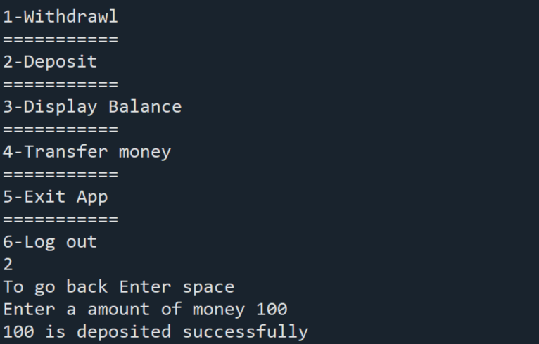
Deposit menu working fine and it does not accept anything but positive numbers.

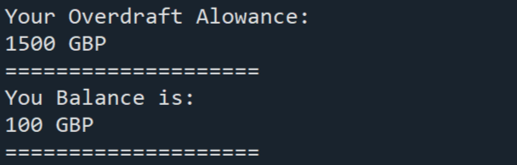
This is what appear when you Display the balance the menu in terms if display balance working correctly.

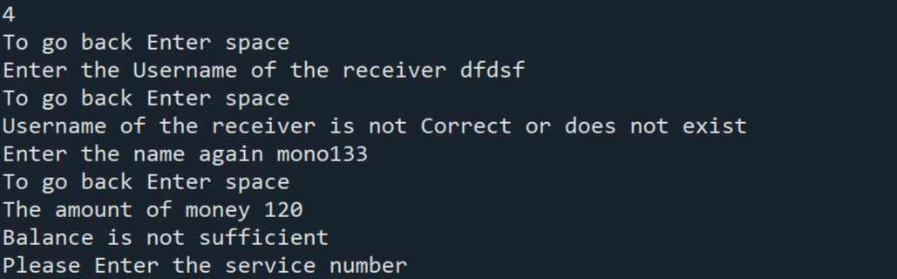
when the user selects the transfer option, they must enter the recipient's username. if the entered username does not exist, they will be prompted to try again until a valid username is provided. after entering a correct username, the user specifies the amount to transfer. if the entered amount (e.g., 120 GBP) exceeds the available balance, a message appears informing them of insufficient funds. the menu functions correctly without any issues.

ID:3075614 , Module: FC723 , Sophie Norman.

- Conclusion of testing
I got 14 tests with 53 cases tested. Most of the tests did go very smoothly, with out any issues. The function required user inputs have been changed to simulate user inputs and to test it in many situations. One function required a additional function to help testing it. I could not test the menus like main app interface and initial menu, because of their complexity when it comes to user inputs possibilities. So I did test them by entering values and test the menu’s options.

